Jupyter Notebook
IPython was originally developed by Fernando Perez in 2001 as an enhanced Python interpreter. A web based interface to IPython terminal in the form of IPython notebook was introduced in 2011. In 2014, Project Jupyter started as a spin-off project from IPython. The IPython Kernel runs the computations and communicates with the Jupyter Notebook front-end interface.
The Jupyter Notebook is an open source web application that you can use to create and share documents that contain live code, equations, visualizations, and text.
Jupyter, comes from the core supported programming languages that it supports: Julia, Python, and R.
- Starting the Jupyter Notebook Server
Type in Anaconda Command Prompt--jupyter notebook
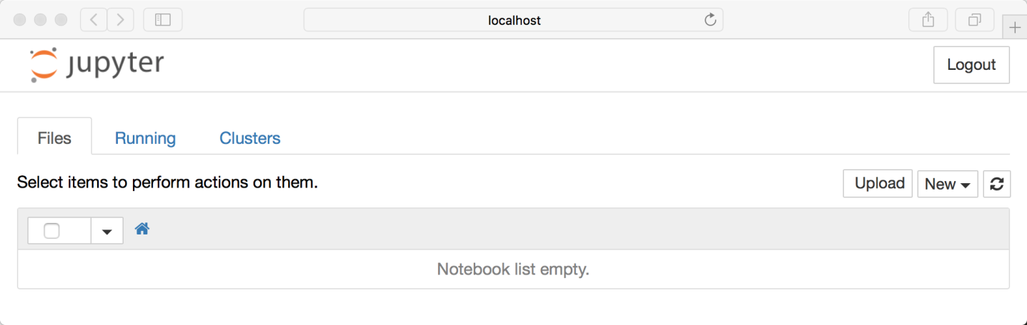
Note that right now you are running the Notebook server. Let’s actually create a Notebook now!

Creating a Notebook
All you need to do is click on the New button (upper right), and it will open up a list of choices. On my machine, I happen to have Python 2 and Python 3 installed, so I can create a Notebook that uses either of these. For simplicity’s sake, let’s choose Python 3.
Your web page should now look like this:
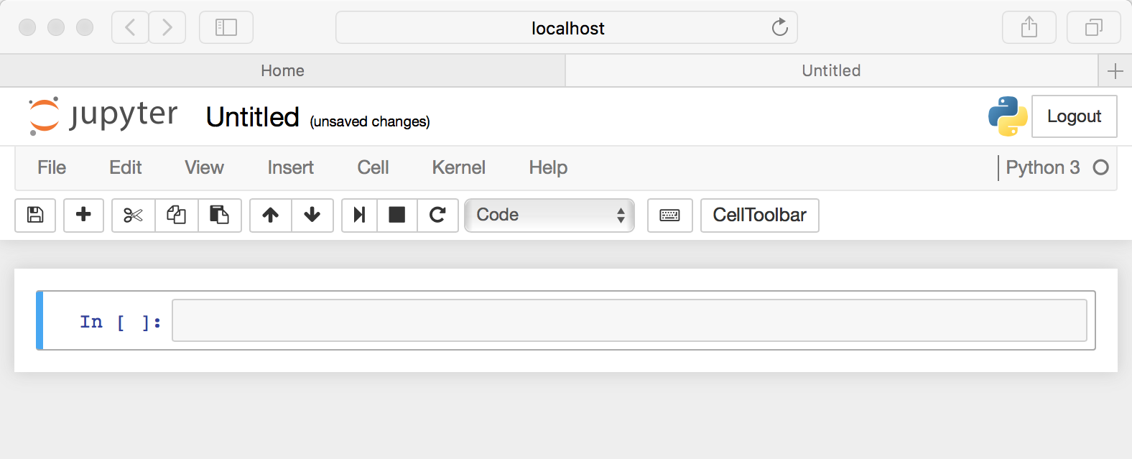

Naming: You will notice that at the top of the page is the word Untitled. This is the title for the page and the name of your Notebook.
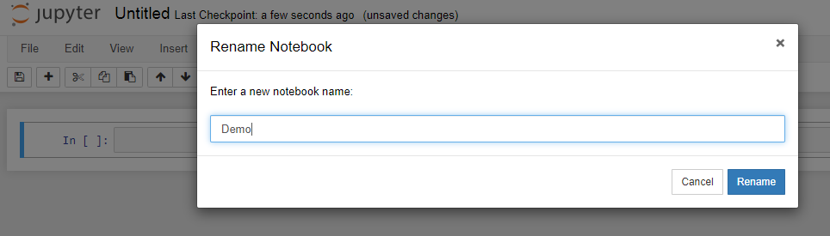

Running Cells
A Notebook’s cell defaults to using code whenever you first create one, and that cell uses the kernel that you chose when you started your Notebook.
In this case, you started yours with Python 3 as your kernel, so that means you can write Python code in your code cells.
Running a cell means that you will execute the cell’s contents. To execute a cell, you can just select the cell and click the Run button that is in the row of buttons along the top. It’s towards the middle. If you prefer using your keyboard, you can just press Shift+Enter.
When I ran the code above, the output looked like this:
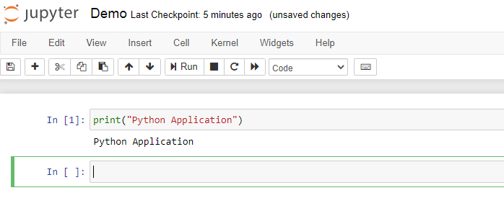
When you run a cell, you will notice that there are some square braces next to the word In to the left of the cell. The square braces will auto fill with a number that indicates the order that you ran the cells. For example, if you open a fresh Notebook and run the first cell at the top of the Notebook, the square braces will fill with the number 1.
- IPython's In and Out Objects
In [1]:/Out[1]: style prompts used by IPython. But it turns out that these are not just pretty decoration: they give a clue as to how you can access previous inputs and outputs in your current session.
In [1]: import math
In [2]: math.sin(2)
Out[2]: 0.9092974268256817

IPython actually creates some Python variables called In and Out that are automatically updated to reflect this history:
In [4]: print(In)
['', 'import math', 'math.sin(2)' , 'print(In)']

In [7]: print(Out[2])
0.9092974268256817
The standard Python shell contains just one simple shortcut for accessing previous output; the variable _ (i.e., a single underscore) is kept updated with the previous output
In [9]: print(_)
1.0
In [10]: print(__)
-0.4161468365471424
here is one more shortcut we should mention, however–a shorthand for Out[X] is _X (i.e., a single underscore followed by the line number):
In [12]: Out[2]
Out[12]: 0.9092974268256817

In [13]: _2
Out[13]: 0.9092974268256817

- Types of Cells
Cells in Jupyter notebook are of three types − Code, Markdown and Raw.

Code Cells
Contents in this cell are treated as statements in a programming language of current kernel.

Markdown Cells
These cells contain text formatted using markdown language. All kinds of formatting features are available like making text bold and italic, displaying ordered or unordered list, rendering tabular contents etc. Markdown cells are especially useful to provide documentation to the computational process of the notebook.

Raw Cells
Contents in raw cells are not evaluated by notebook kernel. When passed through nbconvert, they will be rendered as desired. If you type LatEx in a raw cell, rendering will happen after nbconvert is applied.

Notebooks modes
Jupyter notebooks have two different modes, EDIT and COMMAND.
Edit mode:
To enter the EDIT mode, press ENTER on your keyboard or click in a cell. Edit mode can be identified by green border around the cell with green left margin. When you are in the edit mode, you can type in the cells.Command mode:
To enter the COMMAND mode press ESC or click anywhere outside the cell. You will see grey border around the cell with blue left margin. When you are in Command mode, you can edit your notebook but you can't type in the cells.
- Keyboard navigation:

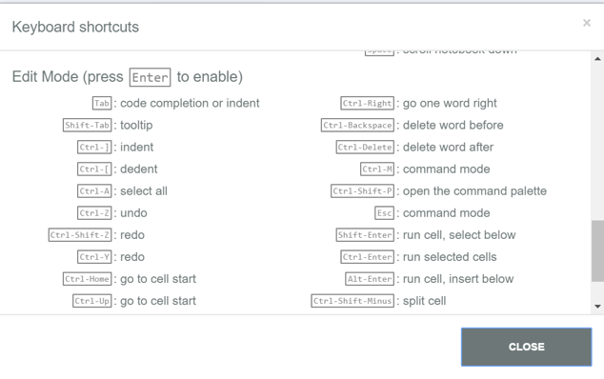
For more keyboard shortcuts, you can refer Help -> Keyboard Shortcuts from Menu bar.
- Delete Existing Jupyter Notebook Files
To delete an existing Jupyter Notebook file (.ipynb), click in the checkbox to left of the filename. You will see a red button with a trashcan appear in the top left of the dashboard menu.
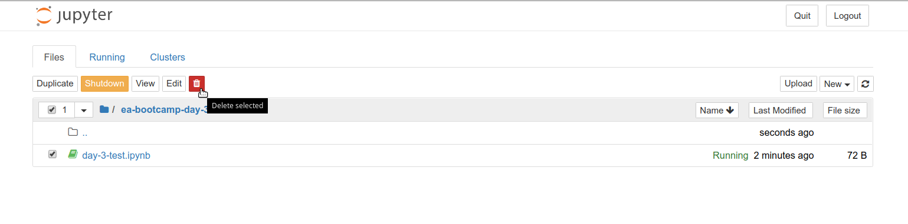
- Create Directories in Jupyter Notebook Dashboard
You can also create new directories from the dashboard to manage your Jupyter Notebook files (.ipynb).
In the Jupyter Notebook dashboard menu, select New and choose Folder.
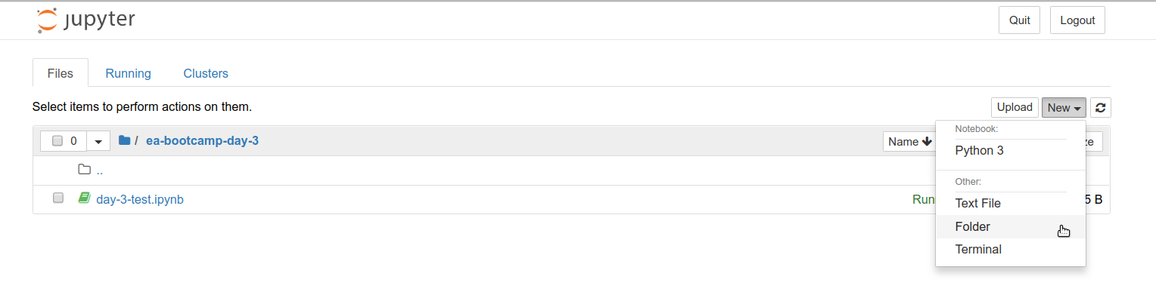 At the top of the new Jupyter Notebook, you will see that the directory is named Untitled.
You can change the name of the directory by clicking in the checkbox to left of the directory name and choosing Rename.
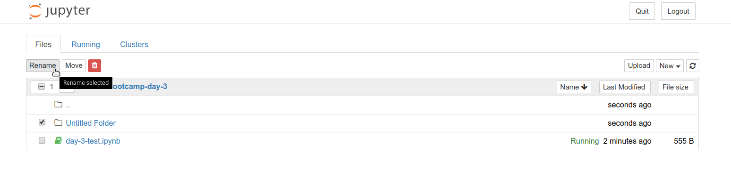
- Move Jupyter Notebook Files
To move an existing Jupyter Notebook file (.ipynb), it needs to be shutdown first.
To Shutdown a Jupyter Notebook file (.ipynb), click in the checkbox to left of the filename. You will see an orange button named Shutdown appear in the top left of the dashboard menu; click on it to Shutdown any file that is checked in the list.
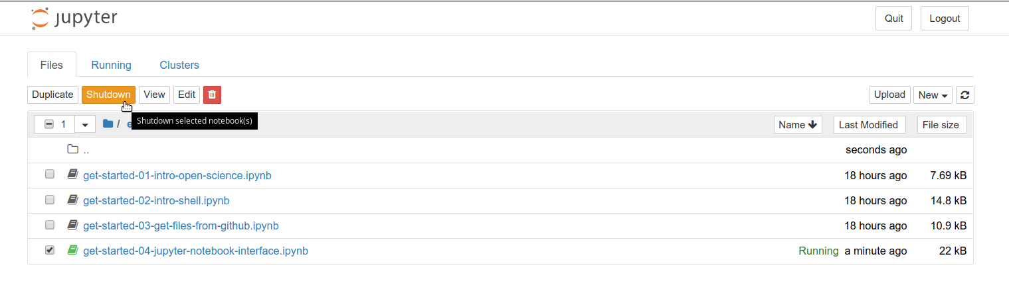
After the notebook is shutdown, you can click in the checkbox to left of the filename and select Move. You will be asked to provide the path to directory to which to move the file.
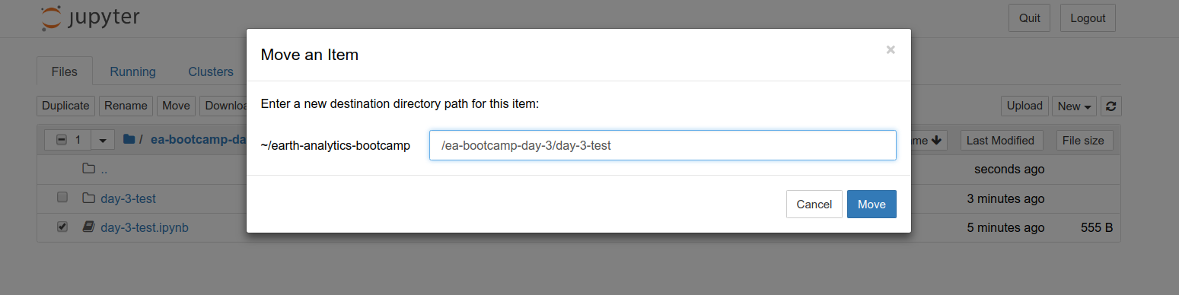

- kernel in Jupyter Notebook
Through Jupyter’s kernel and messaging architecture, the Notebook allows code to be run in a range of different programming languages.
Each kernel is capable of running code in a single programming language and there are kernels available in the following languages:
  - Python
  - Julia
  - R
  - Ruby
  - Haskell
  - Scala

Restarting the kernels--The kernel maintains the state of a notebook’s computations. You can reset this state by restarting the kernel. This is done by clicking on the

- Save and Checkpoint

Every time you create a new notebook, a checkpoint file is created as well as your notebook file; it will be located within a hidden subdirectory of your save location called .ipynb_checkpoints and is also a .ipynb file.

By default, Jupyter will autosave your notebook every 120 seconds to this checkpoint file without altering your primary notebook file. When you “Save and Checkpoint,” both the notebook and checkpoint files are updated.

Hence, the checkpoint enables you to recover your unsaved work in the event of an unexpected issue. You can revert to the checkpoint from the menu via “File > Revert to Checkpoint.”

Exporting Notebooks
Jupyter has built-in support for exporting to HTML and PDF as well as several other formats, which you can find from the menu under “File > Download As.”
Jupyter also has a command line interface in the form of nbconvert option. By default, nbconvert exports the notebook to HTML format. You can use the following command for tis purpose −
jupyter nbconvert mynotebook.ipynb
This will convert mynotebook.ipynb to the mynotebook.html. Other export format is specified with `--to` clause.
jupyter nbconvert --to html --template basic mynotebook.ipynb

LaTex is a document preparation format used specially in scientific typesetting. Jupyter includes 'base', 'article' and 'report' templates.
jupyter nbconvert --to latex –template report mynotebook.ipynb

To generate PDF via latex, use the following command −
jupyter nbconvert mynotebook.ipynb --to pdf

Format Text in Jupyter Notebook with Markdown
Markdown cell allow us:
  - Document your workflow: You can add text to the document that describes the steps of your processing workflow (e.g. how data is being processed and what results are produced).
  - Describe your data: You can describe the data that you are using (e.g. source, pre-processing, metadata).
  - Interpret code outputs: You can add some text that interprets or discusses the outputs.

- Section header
You can create a heading using the pound (#) sign. For the headers to render properly, there must be a space between the # and the header text.
Heading one is denoted using one # sign, heading two is denoted using two ## signs, etc, as follows:
## Heading Two
### Heading Three
#### Heading Four
- List---You can also use Markdown to create lists using the following syntax:
- Set in python
- List in python
- tuple in python

It will be rendered as
- Set in python
- List in python
- tuple in python

one can also create number list as follows:
1. And you can also create ordered lists
2. by using numbers
It will be rendered as

1. And you can also create ordered lists
2. by using numbers

- Bold and Italicize---You can also use ** to bold or * to italicize words.

Example:
* **This is a bullet item with bold words**
* *This is a bullet item with italicized words*
It will render as follows:
- This is a bullet item with bold words
- This is a bullet item with italicized words

- Text color:
Example:
<font color=blue>Sets are mutable</font>
so above content will be rendered in blue color
- Horizontal Lines (Rules)-- You can also create a horizontal line or rule to highlight a block of Markdown syntax
Example:
***

Here is some important text!

***
It will be rendered as
Here is some important text!
- Hyperlinks

[http://www.python.org/](http://www.python.org/)
Will be rendered as
http://www.python.org/
- Images
You can also use Markdown to link to images on the web using the following syntax:
![alt text here](url-to-image-here)
The alt text is the alternative text that appears if an image fails to load on webpage

Local computer images:

Drag and drop image that is in your computer to jupyter notebook markdown cell to render it.
Or

![click me](NEED.jpg)

NEED.jpg must be in a directory where your jupyter notebook is there.
Images from internet:
Inserting an image from the internet is almost identical to inserting a link. You just also type a ! before the first set of brackets:
Example:
![alternate text.](https://www.fullstackpython.com/img/logos/markdown.png)

